GUVI: Zen Class — Part 3: Find the culprits and nail them — debugging javascript

**Fix the code to get the largest of three.**

Code:

aa = (f,s,t) => {  
 let f,s,t;  
 console.log(f,s,t);  
 if(f>s &&f>t){  
 console.log(f)}  
 else if(s>f && s>t){  
 console.log(s)}  
 else{  
 console.log(t)}  
}aa(1,2,3);

CODE:

aa = (f,s,t) => {

    console.log(f,s,t);

    if(f>s &&f>t){

    console.log(f)}

    else if(s>f && s>t){

    console.log(s)}

    else{

    console.log(t)}

   }

   aa(1,2,3);

OUTPUT:

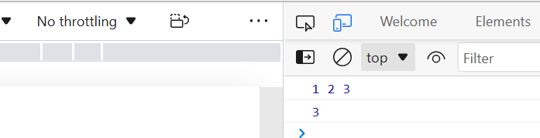

— — — — — — — — — — — — — — — — — — — — — — — — —

**Fix the code to Sum of the digits present in the number**

Code:

let n = 123;console.log(add(n));function add(n)  
{  
let sum = 10;  
for(var i=0;i<n.length;i++){  
 sum+=n[i]  
 }  
 return sum;  
}

CODE:

let n = "123";

console.log(add(n));

function add(n)

{

let sum = 0;

for(var i=0;i<n.length;i++){

 sum+=Number(n[i]);

 }

 return sum;

}

OUTPUT:

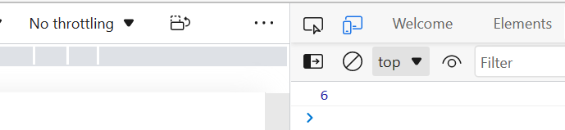

— — — — — — — — — — — — — — — — — — — — — — — — —

**Fix the code to Sum of all numbers using IIFE function**

Code:

const arr = [9,8,5,6,4,3,2,1];(function() {  
 let sum = 0;  
 for (var i = 0; i <= arr.length; i++);{  
 sum += arr[i];  
 }  
 console.log(sum);  
 return sum;  
})();

CODE:

const arr = [9,8,5,6,4,3,2,1];

(function(arr) {

 let sum = 0;

 for(var i=0;i<arr.length;i++){

    sum+=arr[i];

 }

 console.log(sum);

 //return sum;

})(arr);

OUTPUT:

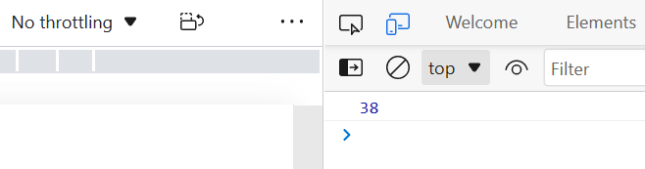+

— — — — — — — — — — — — — — — — — — — — — — — — —

**Fix the code to gen Title caps.**

Code:

var arr = [“guvi”, “geek”, “zen”, “fullstack”];var ano = function(arro) {  
 for (var i = 0; i <= arro.length; i++) {  
 console.log(arro[i][0].toUpperCase() + arro[i].substr(1));  
 }  
}  
ano();

CODE:

var arr = ["guvi", "geek", "zen", "fullstack"];

var ano = function(arro) {

 for (var i = 0; i < arro.length; i++) {

 console.log(arro[i][0].toUpperCase() + arro[i].substr(1));

 }

}

ano(arr);

OUTPUT:

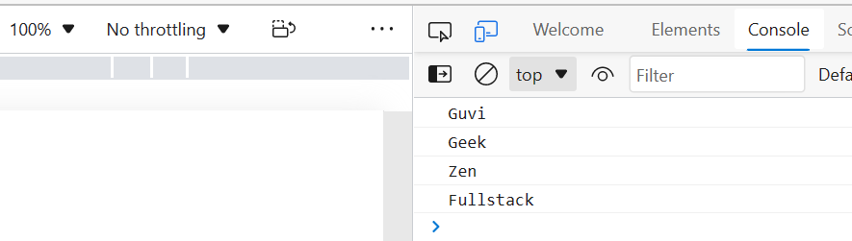

— — — — — — — — — — — — — — — — — — — — — — — — —

**Fix the code to return the Prime numbers**

Code:

const newArray=[1,3,2,5,10];  
const myPrime=newArray.filter(num=>{  
 for(let i=2;i<=num;i++){  
 if(num%i===0)  
 {  
 return true;  
 }  
 }  
 return num===1;  
});  
console.log(myPrime);

CODE:

const newArray=[1,3,2,5,10];

const myPrime=newArray.filter(num=>{

    let flag=0;

 for(let i=2;i<num;i++){

 if(num%i==0)

 {

flag=1;

 }

 }

 if(num!=1){

    if(flag!=1){

        return num;

     }

 }

});

console.log(myPrime);

OUTPUT:

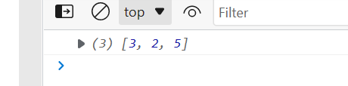— — — — — — — — — — — — — — — — — — — — — — — — —

**Fix the code to sum the number in that array**

Code:

const num = [10, 20, 30, 40,50,60,70,80,90,100]   
const sum = (a, b) =>  
 a + b  
const sum = num.reduce(sum)  
console.log(sum);

CODE:

const num = [10, 20, 30, 40,50,60,70,80,90,100]

let sum = (a, b) =>

 a + b

 sum = num.reduce(sum)

console.log(sum);

OUTPUT:

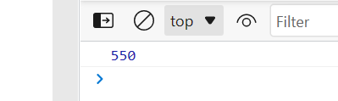

— — — — — — — — — — — — — — — — — — — — — — — — —

**Fix the code to rotate an array by k times and return rotated array using IIFE function**

Code:

var arr = [1, 2, 3, 6, 8, 6, 1, 9, 10, 12, 13];  
var k = 3;  
k = arr.length % k;  
(function() {  
 arr = {};  
 out = arr.slice(k + 1, arr.length);  
 var count = out.length;  
 for (var i = 0; i < k + 1; i++) {  
 out[count] = arr[i];  
 count += 1;  
 }  
 console.log(out);})();

CODE:

var arr = [1, 2, 3, 6, 8, 6, 1, 9, 10, 12, 13];

var k = 3;

k=k-1;

(function() {

 out = {};

 out = arr.splice(k + 1, arr.length);

 var count = out.length;

 for (var i = 0; i < k + 1; i++) {

 out[count] = arr[i];

 count += 1;

 }

 console.log(out);})();

OUTPUT:

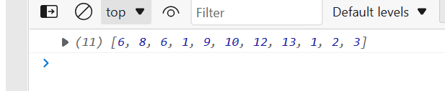

— — — — — — — — — — — — — — — — — — — — — — — — —

**Fix the code to gen Title caps.**

Code:

var arr = [“guvi”, “geek”, “zen”, “fullstack”];(function() {  
 for (var i = 0; i <= arr.length; i++) {  
 console.log(arr[0][i].toUpperCase() + arr[i].substr(1));  
 }  
})();

CODE:

var arr = ["guvi", "geek", "zen", "fullstack"];

(function() {

 for (var i = 0; i < arr.length; i++) {

 console.log(arr[i][0].toUpperCase() + arr[i].substr(1));

 }

})();

OUTPUT:

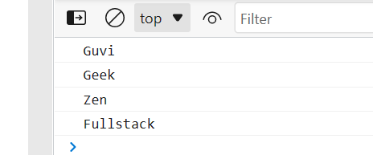

— — — — — — — — — — — — — — — — — — — — — — — — —

**print all odd numbers in an array using IIFE function**

Code:

var arr = [1, 2, 3, 5, 7, 79, 7, 2, 6, 9, 4];(function() {  
 for (var i = 0; i < arr.length; i++) {  
 if (arr[i] % 2 === 0) {  
 console.log(arr[i]);  
 }}  
})();

CODE:

var arr = [1, 2, 3, 5, 7, 79, 7, 2, 6, 9, 4];

(function() {

 for (var i = 0; i < arr.length; i++) {

 if (arr[i] % 2 != 0) {

 console.log(arr[i]);

 }}

})();

OUTPUT:

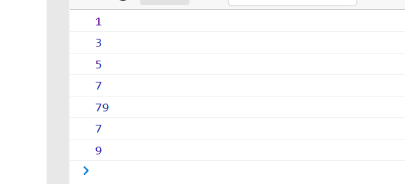

— — — — — — — — — — — — — — — — — — — — — — — — —

**Fix the code to reverse.**

Code:

(function(str){  
 str1 = str.split(“ “).reverse().join(“”);  
 console.log(str1);   
})(“abcd”)

CODE:

(function(str){

   let str1 = str.split("").reverse().join("");

    console.log(str1);

   })("abcd")

OUTPUT:

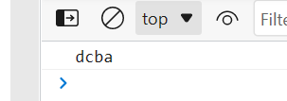

— — — — — — — — — — — — — — — — — — — — — — — — —

**Fix the code to remove duplicates.**

Code:

var res = function(arr){  
 for(var i=0; i < arr.length; i++){  
 newArr = [];  
 if(newArr.indexOf(arr[i]) == -1) {  
 newArr.push(arr[i]);  
 } }  
 console.log(newArr)  
}res([“guvi”,”geek”,”guvi”,”duplicate”,”geeK”])

CODE:

var res = function(arr){

    newArr = [];

    for(var i=0; i < arr.length; i++){

    if(newArr.indexOf(arr[i]) == -1) {

    newArr.push(arr[i]);

        }

    }

    console.log(newArr)

   }

   res(["guvi","geek","guvi","duplicate","geeK"])

OUTPUT:

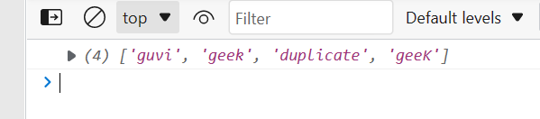

— — — — — — — — — — — — — — — — — — — — — — — — —

**Fix the code to give the below output:**

Expected Output:

[  
{firstName: “Vasanth”, lastName: “Raja”, age: 24, role: “JSWizard”},  
{firstName: “Sri”, lastName: “Devi”, age: 28, role: “Coder”}  
]

Code:

var array =[[[“firstname”,”vasanth”],[“lastname”,”Raje”],[“age”,24],[“role”,”JSWizard”]],[[“firstname”,”Sri”],[“lastname”,”Devi”],[“age”,28],[“role”, “Coder”]]];  
var final=[]  
while(array.length!=0)  
{  
 var outer_remove = array.shift();  
   
 while(outer_remove.length!=0)  
 {  
 var inner_remove = outer_remove.shift()  
 var key = inner_remove[0]  
 var value =inner_remove[1]  
 new_object[key]=value  
 }  
 final.push(new_object)}

CODE:

var array =[[["firstname","vasanth"],["lastname","Raje"],["age",24],["role","JSWizard"]],[["firstname","Sri"],["lastname","Devi"],["age",28],["role", "Coder"]]];

var final=[]

while(array.length!=0)

{

 var outer_remove = array.shift();

 let new_object={}

 while(outer_remove.length!=0)

 {

 var inner_remove = outer_remove.shift()

 var key = inner_remove[0]

 var value =inner_remove[1]

  new_object[key]=value

 }

 final.push(new_object)

}

console.log(final)

OUTPUT:

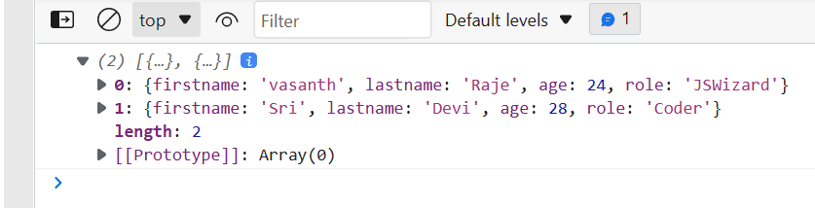

— — — — — — — — — — — — — — — — — — — — — — — — —

**Fix the code to give the below output:**

Sum of odd numbers in an array

Code:

var as=[12,34,5,6,2,56,6,2,1];  
var s=as.reduce(function(a,c){  
 if(c%2!=0)  
 {  
 return a+c;  
 }  
 return a;});  
console.log(s);

CODE:

var as=[12,34,5,6,2,56,6,2,1];

var s=as.reduce(function(a,c){

 if(c%2!=0)

 {

 return a+c;

 }

 return a;},0);

console.log(s);

OUTPUT:

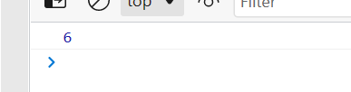

— — — — — — — — — — — — — — — — — — — — — — — — —

**Fix the code to give the below output:**

Swap the odd and even digits

Code:

aa = data=>{  
 var a=data;  
for(i=0;i<a.length-1;i++){  
 var l=’’;  
 var s=a[i+1]  
 var b=a[i]  
 l+=s  
 l+=b  
 i=i+1  
}  
if((a.length%2)!=0){  
 l+=a[a.length-1]  
}  
console.log(l);  
}aa(“1234”);

CODE:

aa = (data)=>{

    var a=data;

    var l='';

   for(i=0;i<a.length;i=i+2){

    var s=a[i+1]

    var b=a[i]

    l+=s;

    l+=b;

   }

   if((a.length%2)!=0){

    l+=a[a.length-1]

   }

   console.log(l);

   }

   aa("1234");

OUTPUT:

